Case 7-AM,C-Moche-Headdress-Owl-Gold-100 BCE-400 CE 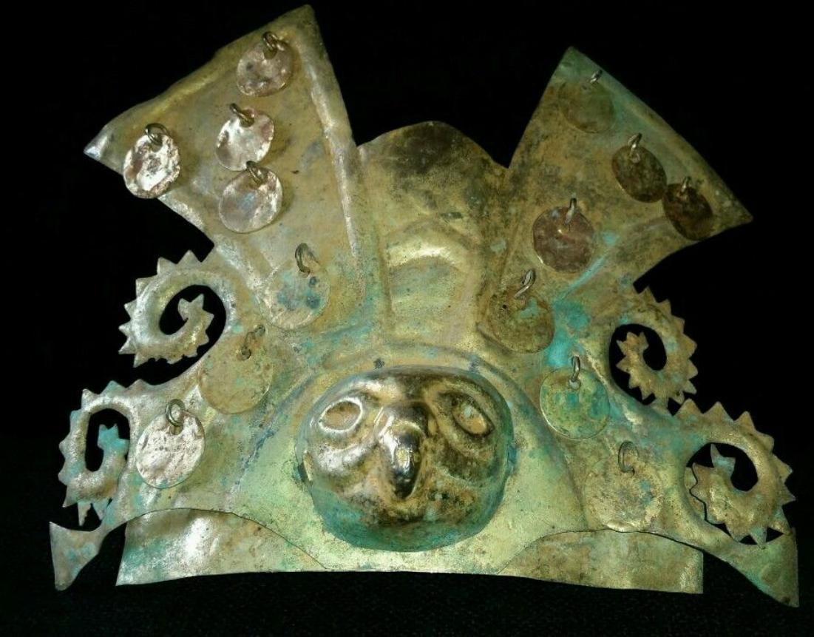
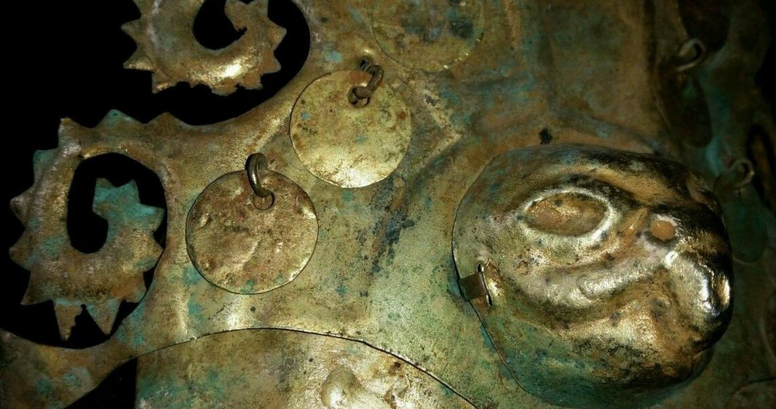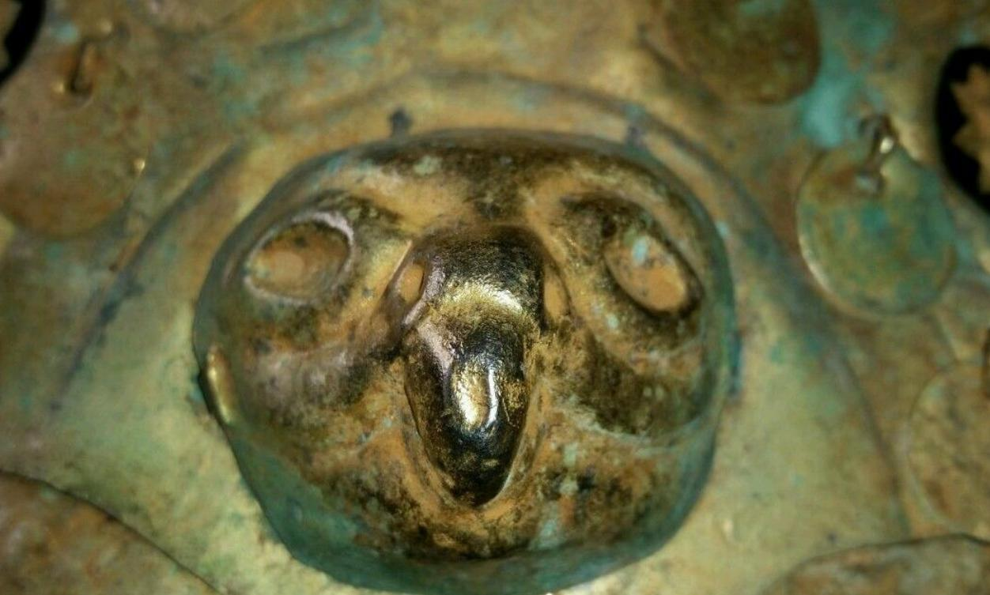
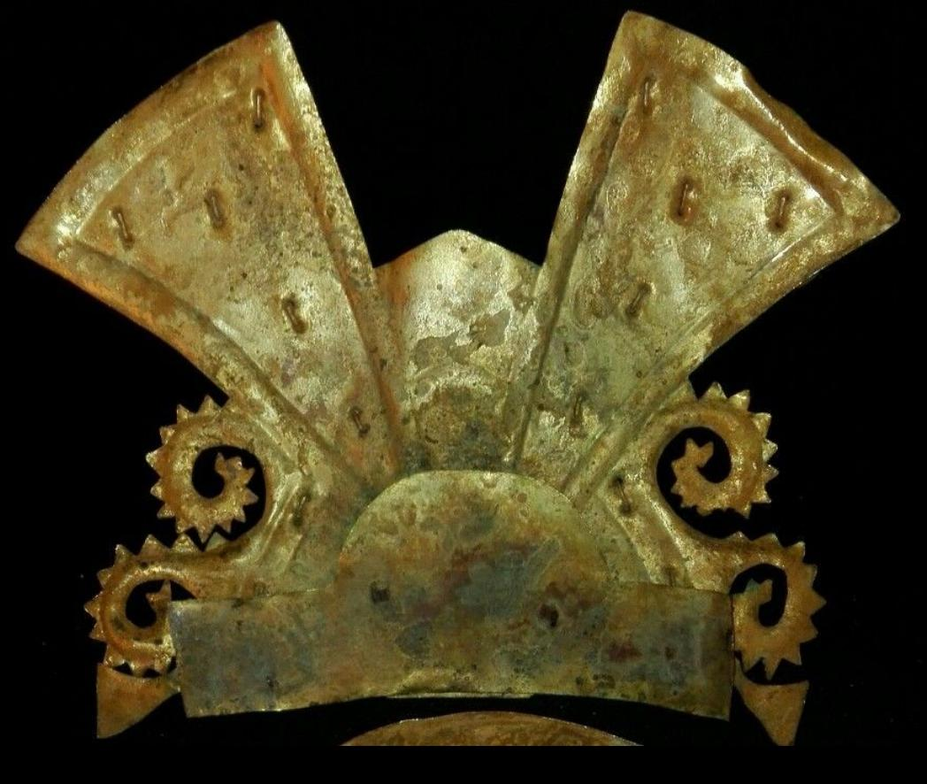
Figs. 1-2. Peru-Moche-Mask-Nosepiece-Copper-Owl Head Effigies.
Case no.: 7
Accession Number: A74
Formal Label:
Display Description:
A large copper mask of a male dignitary with a lineal-woven textile cap. He has almond-shaped eyes, a broad nose and fully shaped ears. A wide crown with stepped pyramidal structures on either side in which are eleven “V”-shaped hanging, copper spangles. At the center of the crown is an owl maskette within a lunette. Below the face are an additional five owl maskettes. The figure is wearing large, round ear disks outlined by a ridge in which are eight circular copper sequins surrounding a central boss. A large crescent-shaped nose ornament with twelve copper spangles (three are missing) is attached to the nose. This is an unusual mask in that both sides offer different vantage points of viewing the dignitary: the reverse show him in his regalia with his mouth sewn shut as in death and the obverse shows him in a more natural pose in life without his regalia.
LC Classification: F3430.1.
Date or Time Horizon: 100 BCE-400 CE
Geographical Area: N coastal Peru
Map, GPS coordinates:
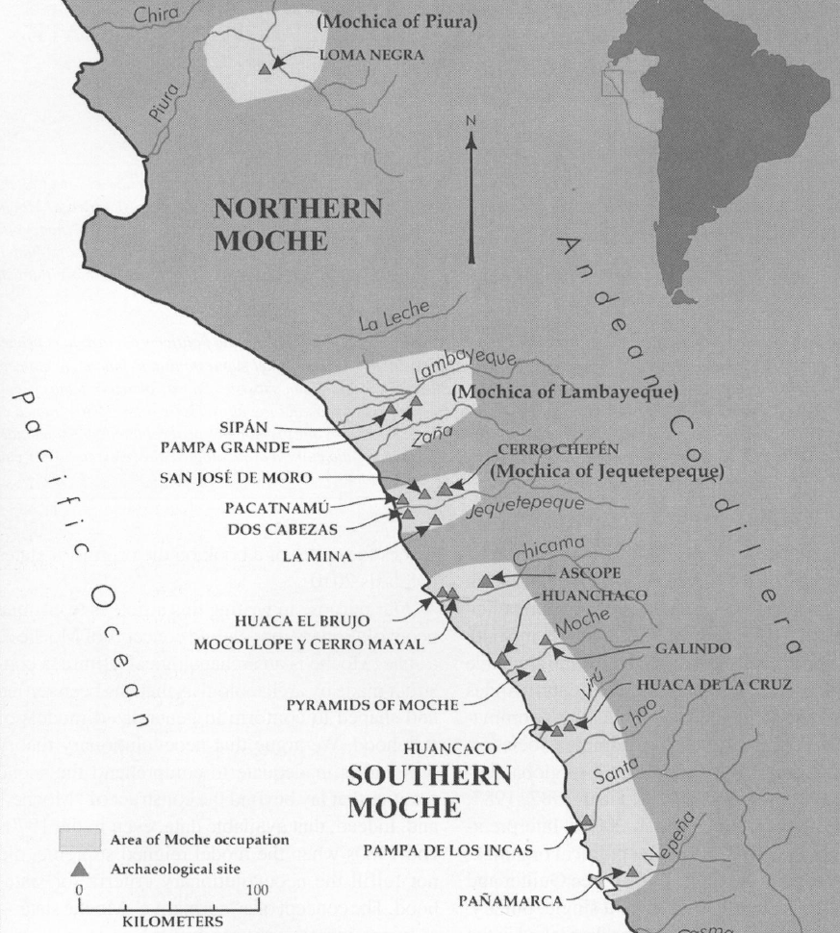
Fig. 3. Map of Moche regions as currently conceived and significant Moche sites. Map courtesy Moro Archaeological program.
Cultural Affiliation: Moche (Mochica)
Medium: Copper sheet with heavy encrusted verdigris patina. Ancient, cuprite and metallic sediment deposits yields a beautiful olive-green to brown patina on reverse and olive-green on obverse.
Dimensions: H226.73 mm, 8.93 in;
Weight: 357 gm, 12.50 oz.
Condition: Original. Ancient, cuprite and metallic sediment deposits yields a beautiful olive-green to brown patina on reverse and olive-green on obverse.
Provenance: Ex. Arte Primitivo, Ex. Howard Nowes Gallery “Art for Eternity”.

Discussion: Owl maskettes were worn as pendants as the following example illustrates:
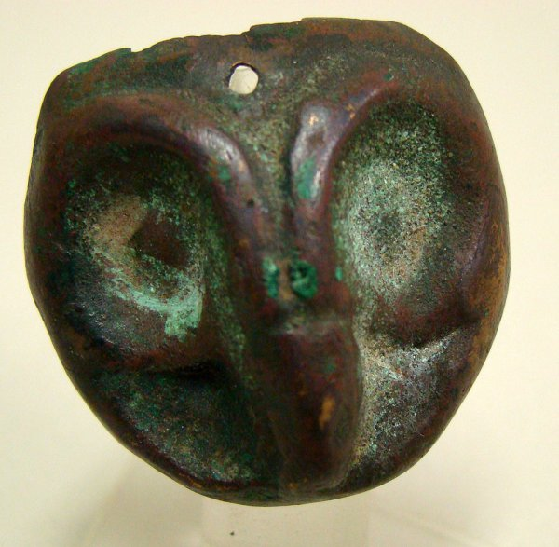
Moche, 500 – 800 AD/CE. A small and fine copper mask in the form of the head of an "owl". Mask is circular shaped with typically large eyes and long and narrow pointed beak. Hole appears at the center top portion of mask. Perhaps was worn as a pendant on a necklace. Nice patina with slight losses at extreme top portion. D: 1 3/8". Sits nicely on custom Lucite stand. Joel L. Malter Collection. From https://p1.liveauctioneers.com/95/13904/428286
_1_l.jpg?version=1191273765

References:
Berezkin, Yuri. 1980. “An Identification of Anthropomorphic Mythological Personages in Moche Representations,” Ñawpa Pacha, 18:1-26.
Quilter, Jeffrey. 1990. “The Moche Revolt of the Objects,” Latin American Antiquity, 1:42-65.
Quilter, Jeffrey.1997. “The Narrative Approach to Moche Iconography,” Latin American Antiquity, 8:113-133.
Quilter, Jeffrey. 2002. “Moche Politics, Religion, and Warfare,” Journal of World Prehistory, 16:145-195.
Quilter, Jeffrey. 2008. “Art and Moche Martial Arts.” In The Art and Archaeology of the Moche, edited by Bourget, Steve and Kimberly L. Jones, pp. 215-228. Austin: University of Texas.
Quilter, Jeffrey. 2010. Moche: Media and Messages. Cambridge: Peabody Museum Press, Harvard University.
Quilter, Jeffrey, and Luis Jaime Castillo Butters (editors) 2010. New Perspectives on Moche Political Organization. Cambridge: Dumbarton Oaks.
Quilter, Jeffrey, and Michele L. Koons, M. 2012. “The fall the Moche: a critique of claims for South America’s first state,” Latin American Antiquity, 23(2), 127-143.

ORDER DATE  Mar 18, 2016 | ORDER TOTAL  US $820.00  + US $25.00  shipping  Order PRE-COLUMBIAN CROWN GOLD TUMBAGA MOCHE Leave feedback - ORDER DATE Mar 18, 2016View order details - ORDER DATE Mar 18, 2016  More actions - ORDER DATE Mar 18, 2016
1 item sold by mmda.ludisa
  PRE-COLUMBIAN CROWN GOLD TUMBAGA MOCHE  ( 252317368132 )  Delivered on Thu, Mar 24  Tracking number: Tracking number9505500024846082000105  Add note | ITEM PRICE:  US $820.00
2 items sold by mmda.ludisa
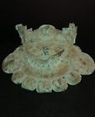  PRE-COLUMBIAN MASK OF COPPER MOCHE  ( 252309300914 )  Delivered on Mon, Mar 21  Tracking number: Tracking number9505500024846078000188  Add note | ITEM PRICE:  US $550.00 | Item PRE-COLUMBIAN MASK OF COPPER MOCHE Orders 252309300914-0-0Leave feedbackReturn this item  More actions

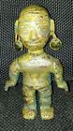  PRE-COLUMBIAN IDOL GOLD TUMBAGA CHAVIN -VICUS  ( 252309372325 )  Delivered on Mon, Mar 21  Tracking number: Tracking number9505500024846078000188  Add note | ITEM PRICE:  US $500.00

